# 

# 

# **PROJECT REPORT**

# **ON**

# **TOURISM MANAGEMENT**

# 

# Submitted by,

# Cicin Sunny

# Emp ID:845438

# Group No:9

# 

# 

# Contents

|  |  |  |
| --- | --- | --- |
| Serial No. | Title | Page no. |
| 1. | Abstract | 2 |
| 2. | Introduction | 3 |
| 3. | Requirement Specification   Hardware Requirements  Software Requirements | 4 4 4 |
| 4. | Architecture Design | 6 |
|  | Outline of project   Relational Database Schema  Snapshots | 6 7 8 |
| 5. | Conclusion and future scope | 11 |
| 6. | References | 12 |

# Abstract

Most of the people in this world like to travel from one place to another no matter whether it is a small or large distance. The need for a tourism management system that can manage tourism information with ease is sought after by every tour management company. Tour Management system is a dynamic website for tourism business. This travel and tourism application is designed for travel agencies by which they can manage different tour packages based on the destinations. By using this, the tour company can tailor tour packages spanning various destinations at almost every price point. The also implemented search module allows the administrator to find and update or upgrade the tour packages with ease. This module can also even be extended to a customer application page by which customers can find the right tour package for them at every budget, depending on the tour locations. The main purpose is to help tourism companies to manage tour packages . The system can also be used for both professional and business trips. The proposed system maintains a centralized repository to make necessary travel arrangements and to retrieve information easily.

# 

# Introduction

Tourism has turned out to be an economic booster contributing to the economic development of many countries over the last few decades. People see holidays as a necessity, and not as luxury in the present scenario. Tourism calls for coordination and cooperation between travel agents, tour operators, and tourists. Tourism has a few major elements − destinations, attractions, sites, accommodation, and all ancillary services. The need for a robust and dynamic tour management application has been around since the advent of the tourism concept.

Thus we have developed an application to provide the best travelling services to the customers and travel agents. The Tourism Management System provides a search platform where a tourist can find their tour places according to their choices. This system also helps to promote responsible and interesting tourism so that people can enjoy their holidays at their favorable places and develop tourism with different cultures so that they enrich the tourism experience and build pride.

The Tourism Management System is a web based application.The objective of this project is to develop a system that automates the processes and activities of a travel agency. It is tedious for a customer to plan a particular journey and have it executed properly. This project is developed to replace the currently existing system, which helps in keeping records of the customer details of destination as well as payment received.The proposed system is highly automated and makes the travelling activities much easier and flexible. The users can get the very right information at the very right time.This will increase the trust of the customer into the tourism company as well.

This project is designed with SQL Server as back end. All the data will be stored in the server and in case of any data losing situation, a backup will be available by this server. The details related to every aspect of the tourist will be available separately. Users just have to click once and all the details will be available to them.

# 

# Requirement Specification

## Hardware Requirements

|  |  |
| --- | --- |
| PROCESSOR | Intel® Celeron® Processor 847, 1.10 GHz, or equivalent |
| STORAGE | Between 1.3 GB - 2.3 GB |
| RAM | Minimum of 512 MB. The recommended amount can vary depending on the number of users connected and other factors. |
| HARD DISK | 3 GB of available hard-disk space for installation, additional free space is required during installation. |

## 

## Software Requirements

1. Java 1.8+

JDK is an acronym for Java Development Kit. The Java Development Kit (JDK) is a software development environment which is used to develop java applications and applets. It physically exists. It contains JRE + development tools. JDK is an implementation of any one of the below given Java Platforms released by Oracle corporation: Standard Edition Java Platform, Enterprise Edition Java Platform, Micro Edition Java Platform. The JDK contains a private Java Virtual Machine (JVM) and a few other resources such as an interpreter/loader (Java), a compiler (javac), an archiver (jar), a documentation generator (Javadoc) etc. to complete the development of a Java Application.

1. Tomcat Server 7.0 or above

Tomcat is an application server designed to execute **Java** servlets and render web pages that use **Java** Server page coding. Accessible as either a binary or a source code version, Tomcat's been used to power a wide range of applications and websites across the Internet.As a Java Servlet container that provides extended functionality to interact with Java Servlets, Tomcat is a powerful option to execute Java servlets and render web pages that use Java Server page coding. Tomcat enables a pure Java web server environment, bringing together Java-based technologies to run applications built on Java programming language. While its flexibility and interoperability enable Apache Tomcat to behave as a web application server under certain conditions, its true identity is primarily as a Java servlet container.

1. MySQL database 5.0 or above

MySQL is an Oracle-backed open source relational database management system (RDBMS) based on Structured Query Language (SQL). MySQL runs on virtually all platforms, including Linux, UNIX and Windows. Although it can be used in a wide range of applications, MySQL is most often associated with web applications and online publishing.

1. Eclipse IDE / STS 2018-2019

Eclipse is an integrated development environment (IDE) used in computer programming.[6] It contains a base workspace and an extensible plug-in system for customizing the environment. Eclipse is written mostly in Java and its primary use is for developing Java applications, but it may also be used to develop applications in other programming languages via plug-ins, including Ada, ABAP, C, C++, C#, Clojure, COBOL, D, Erlang, Fortran, Groovy, Haskell, JavaScript, Julia, Lasso, Lua, NATURAL, Perl, PHP, Prolog, Python, R, Ruby (including Ruby on Rails framework), Rust, Scala, and Scheme. It can also be used to develop documents with LaTeX (via a TeXlipse plug-in) and packages for the software Mathematica. Development environments include the Eclipse Java development tools (JDT) for Java and Scala, Eclipse CDT for C/C++, and Eclipse PDT for PHP, among others.

1. Maven 3.0 or above

Maven is a software project management and comprehension tool. Based on the concept of a project object model (POM), Maven can manage a project’s build, reporting and documentation from a central place.

1. Junit 4

JUnit is a unit testing framework for the Java programming language. JUnit has been important in the development of test-driven development, and is one of a family of unit testing frameworks. Its main use is to write repeatable tests for our application code units.

# Architecture Design

## Outline Of The Project

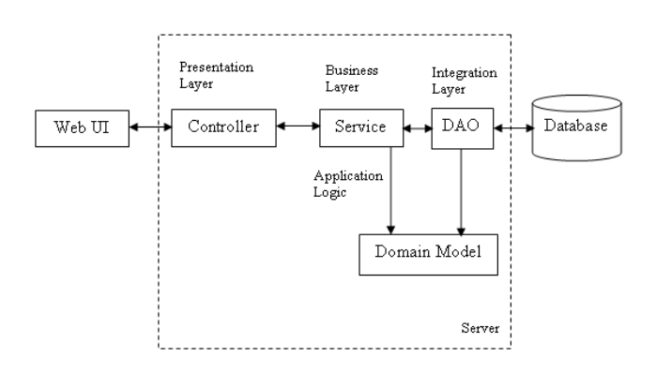

The whole software design can be divided mainly into 3 parts - WebUI, a middleware layer and a persistence layer. This project is developed for a tourism manager where he is able to add new tourists, update/delete the tourist details. It also has a search module where the user can search the tourist names based on their from and to locations.

Technology across different layers:

|  |  |
| --- | --- |
| **Technology Layer** | **Category** |
| Presentation Layer / Web UI | HTML5, CSS3, Javascript, JSTL, Spring MVC UI Components etc. |
| Middleware Layer | Spring MVC components |
| Persistence provider | Hibernate with MySQL 5+ version database |

## 

## Relational Database Schema

The data is stored in a database that is developed in MySQL. The database consists of two tables. Data of a tourist means details such as ID, name, from location, to location, no. of days and the price of tour package with ID as the primary key which is placed in a table tour package. The user table has the data like username and password for login that enables the admin to manipulate the information regarding each tourist.  
  
EER Diagram of Tourism Project Database:  
 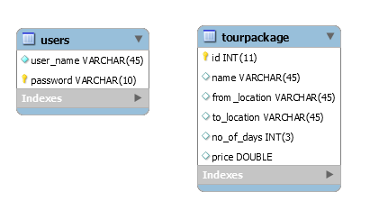

## Snapshots

1. **Home page**

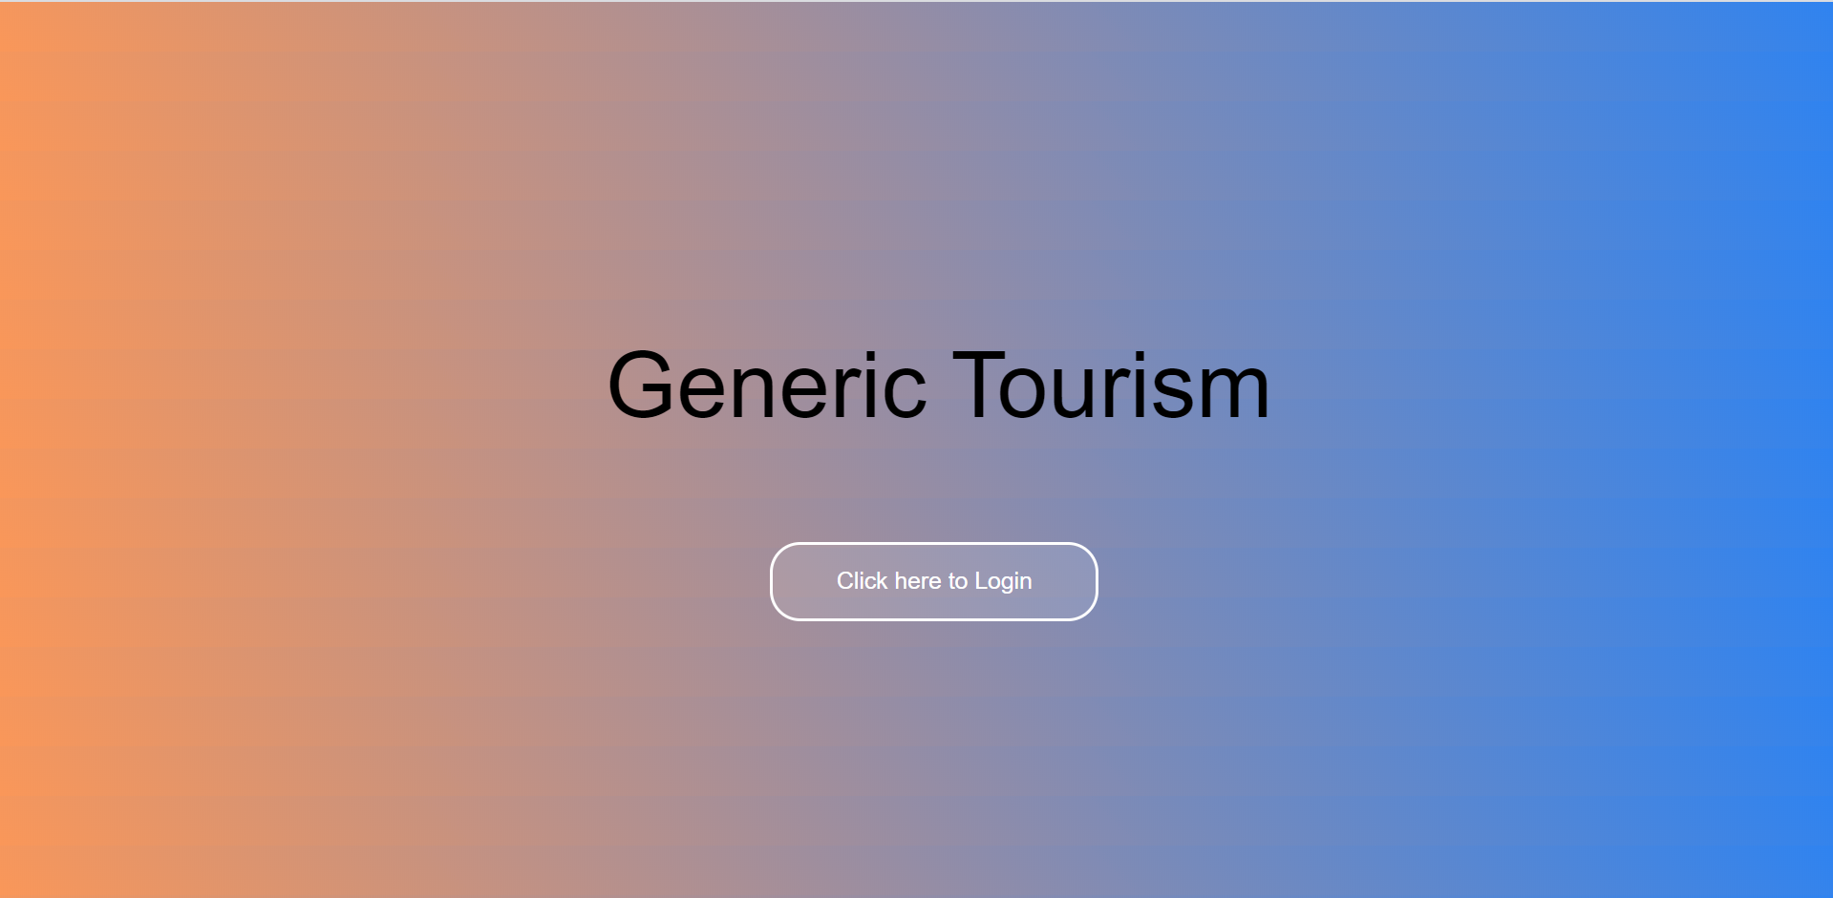

1. **Login page**

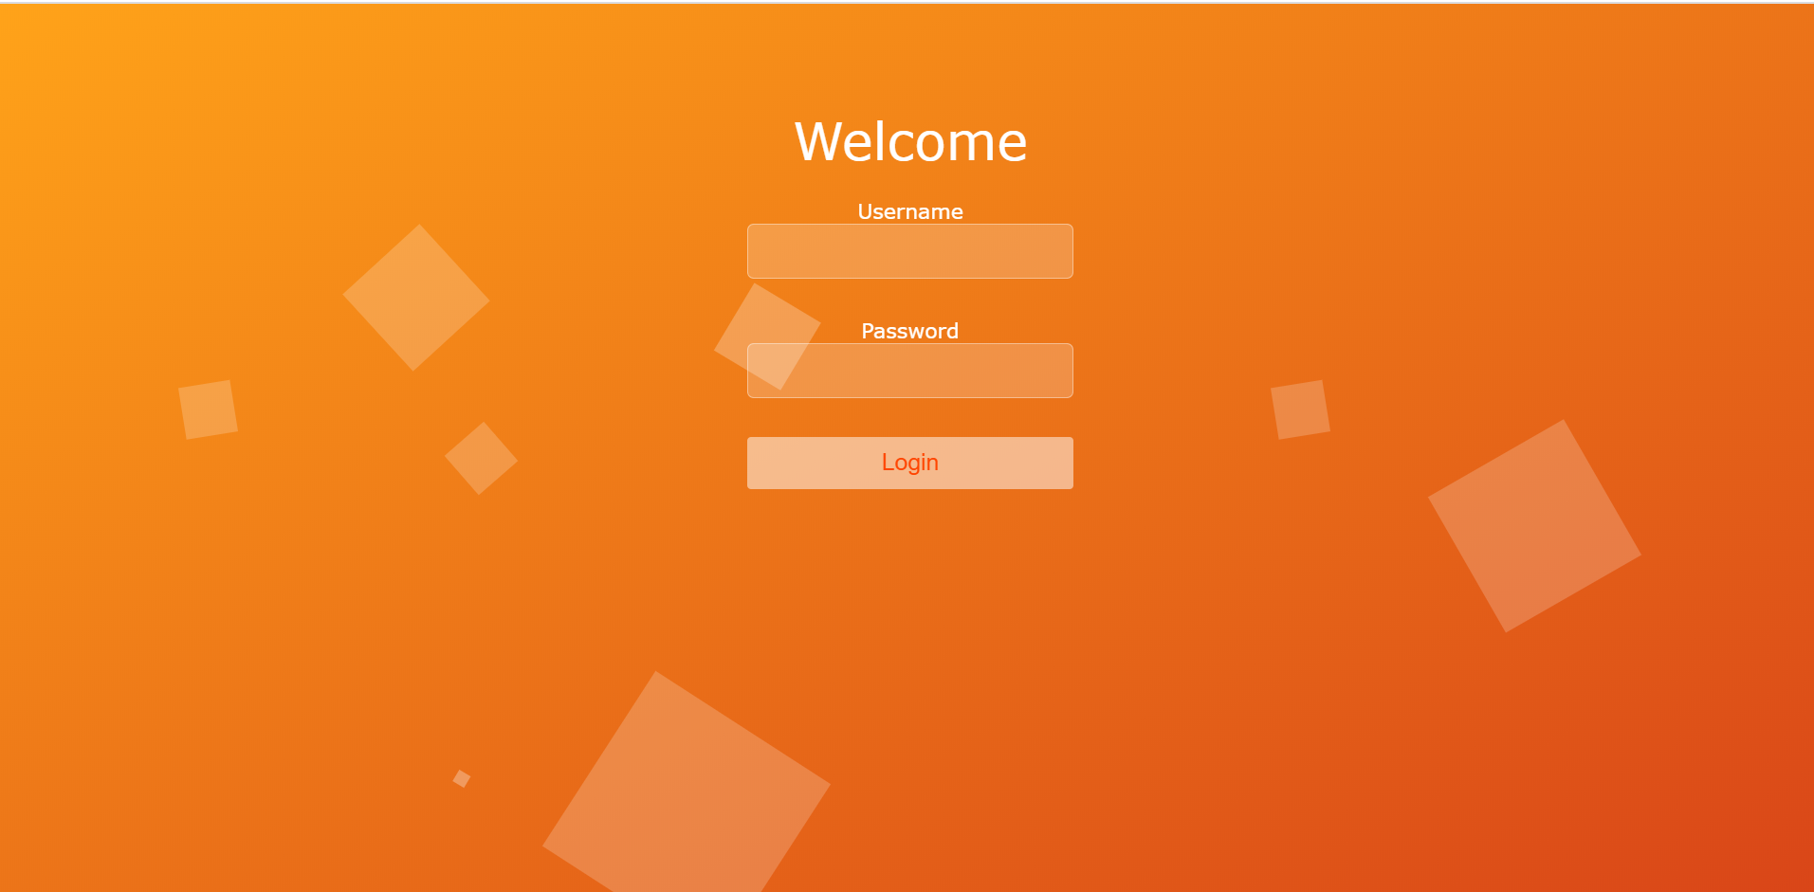

1. **Tourism Package List**

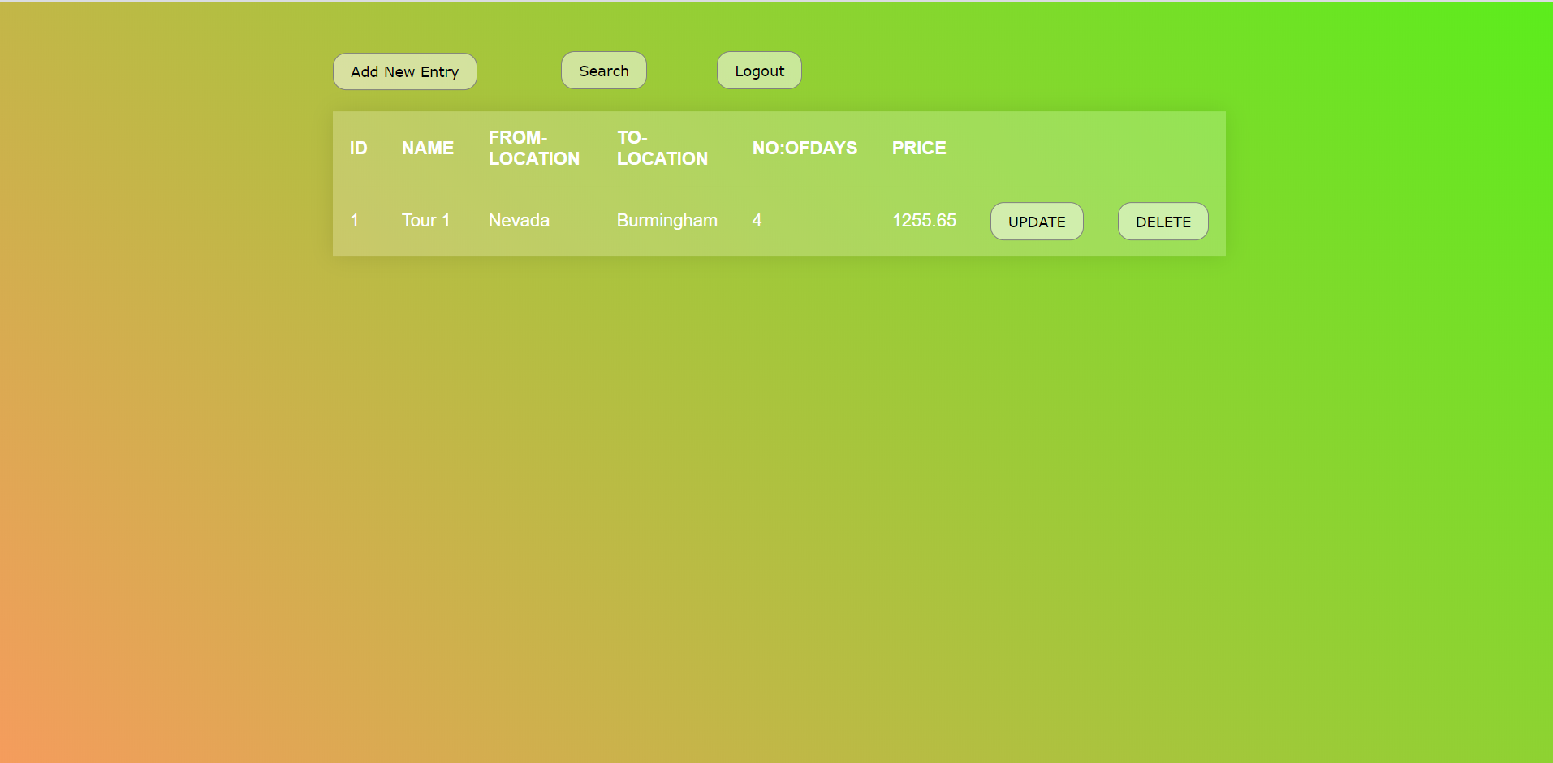

1. **Add Form**

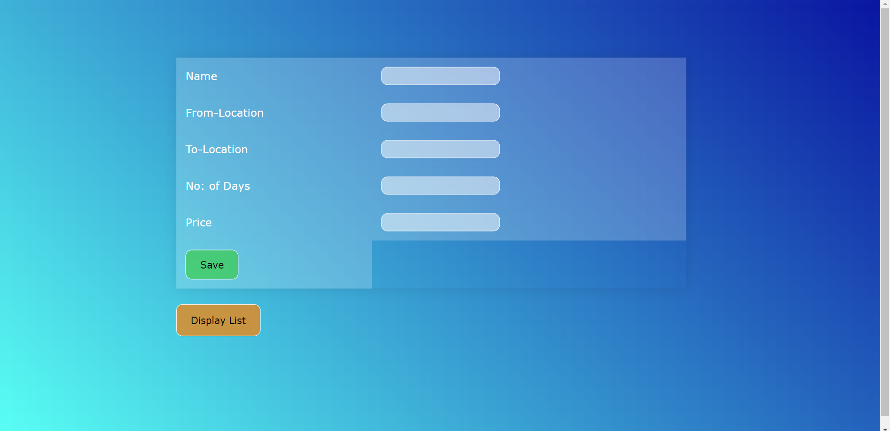

1. **Search By Location**

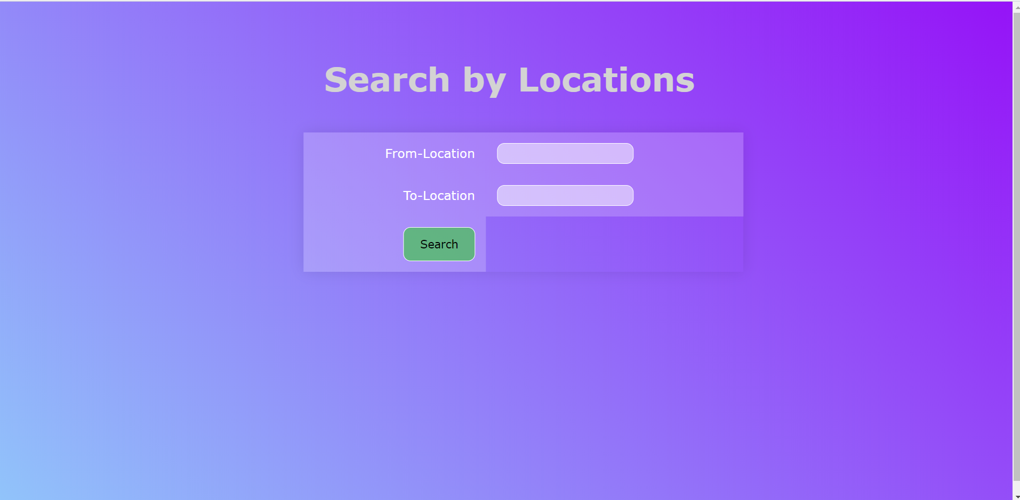

# Conclusion And Future Scope

Tourism is currently recognized as a global industry which is growing at a high rate like any other industry. Access to relevant and accurate information is at the heart of tourism. Here, the proposed project on Tourism Management System tries to bridge the gap by noting what a tourist perceives as relevant. Hence, the aim of this project entails the design and implementation of a platform that will assist tourists in gaining access to travel to various tourist locations. The project also helped to provide knowledge about the latest technology used in developing web enabled application and client server technology that will be in great demand in future.

It is worth mentioning that this project work is open for further enhancement, with the expectation that it becomes more robust and better enhanced; covering every single tourist site. For a modified system, the user needs to just login into the application and can find the routes,costs,hotels,adventure sports,transportations and book immediately and complete the booking process for a successful transaction.

In the aspect of tourism, Internet and web technologies have made more readily available information on tourist locations, accommodations, transportation, shopping, food, festivals, and other attractions, thus improving the whole tourism experience.

# References

1.<https://docs.spring.io/spring/docs/current/spring-framework-reference/>

2.[https://docs.spring.io/spring/docs/current/spring-framework-reference/core.html#sprin g-core](https://docs.spring.io/spring/docs/current/spring-framework-reference/core.html" \l "spring-core)

3.<https://docs.spring.io/spring/docs/current/spring-framework-reference/web.html>

4.<https://hibernate.org/orm/documentation/5.0/>

5.<https://maven.apache.org/guides/getting-started/index.html>